Class test-3

AADITYA PARTIBAN

192211037

Prg1- to print fibbonaci series recursively

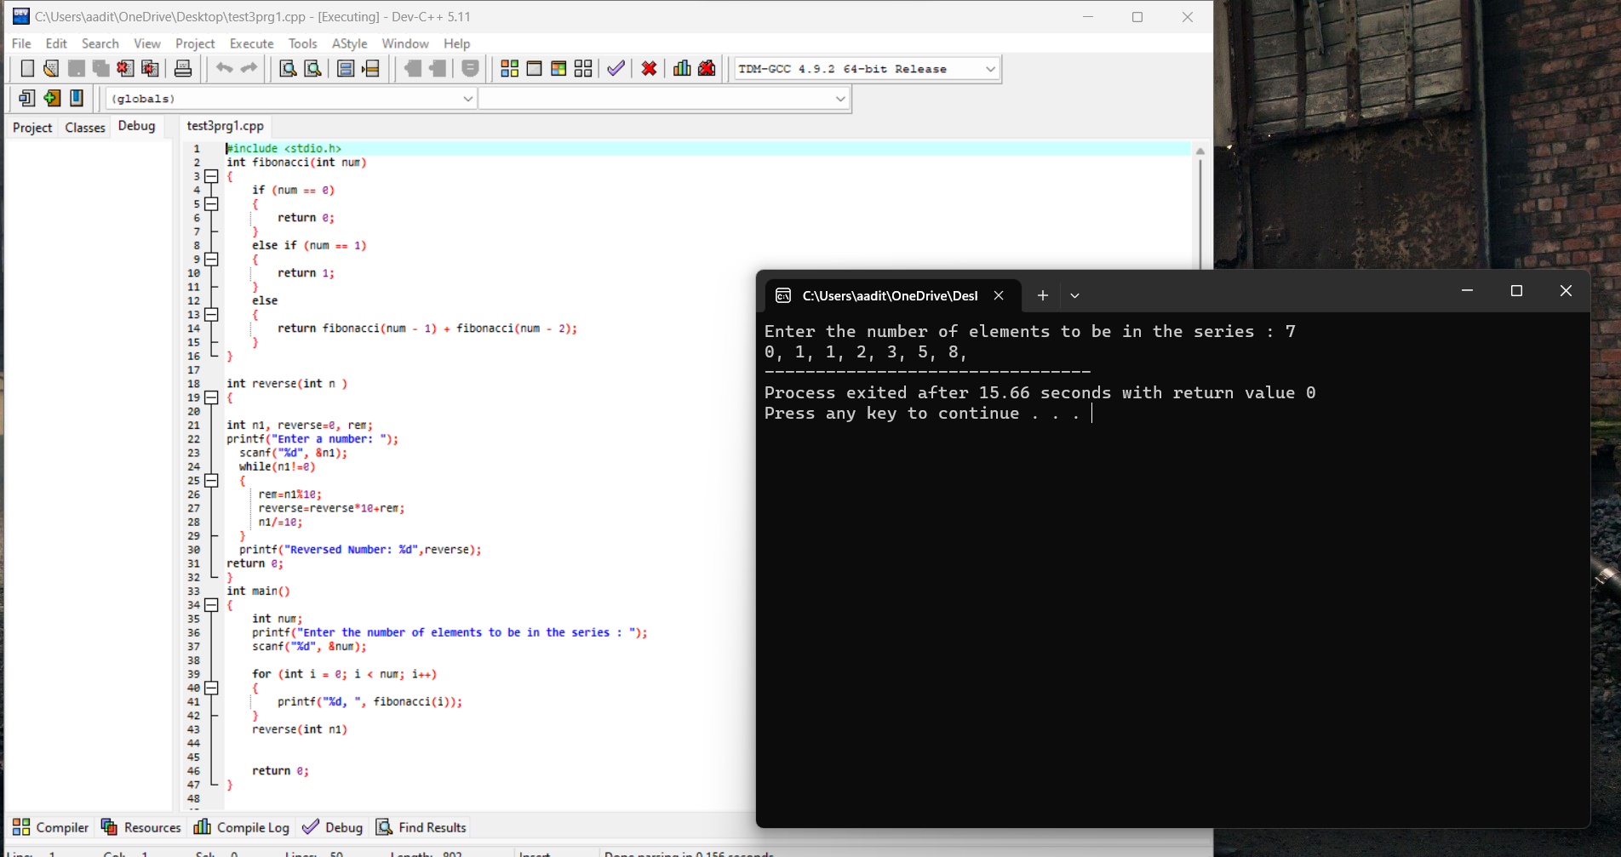

Prg 2- to print multiple numbers using function

